 | Softball 4 FUN (Ages 6 to 16) and  Tee-Ball 4 FUN (Ages 3 to 5) REGISTRATION
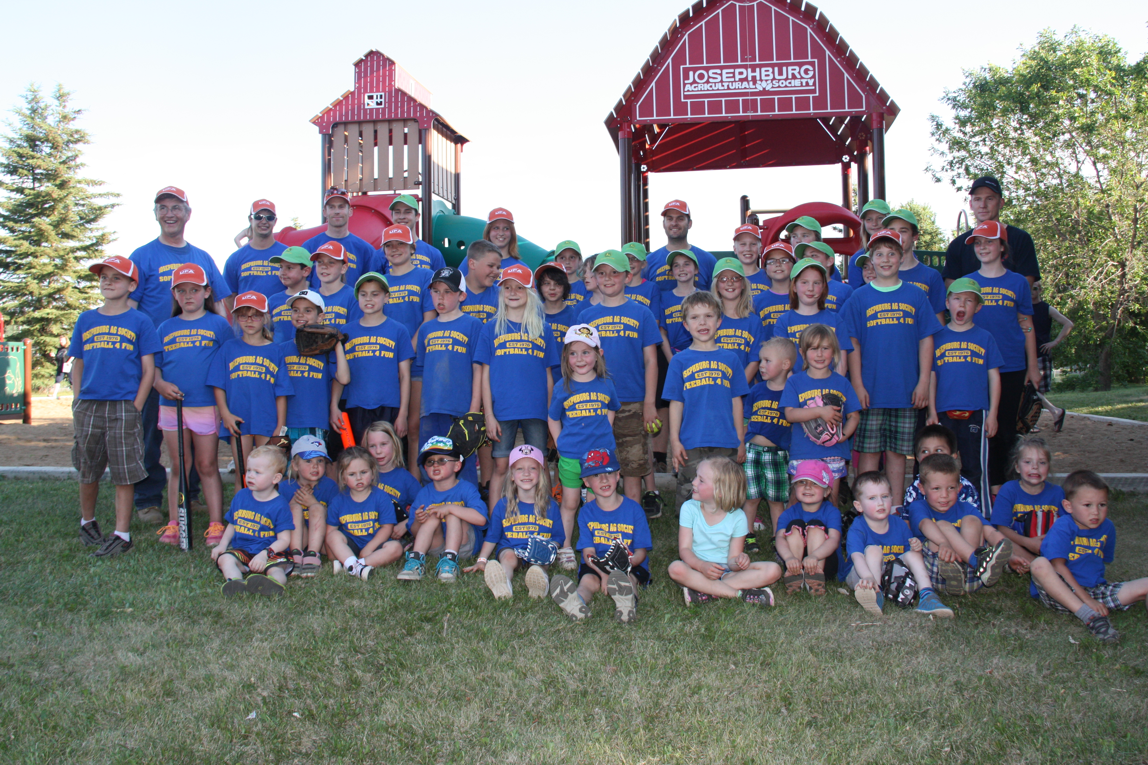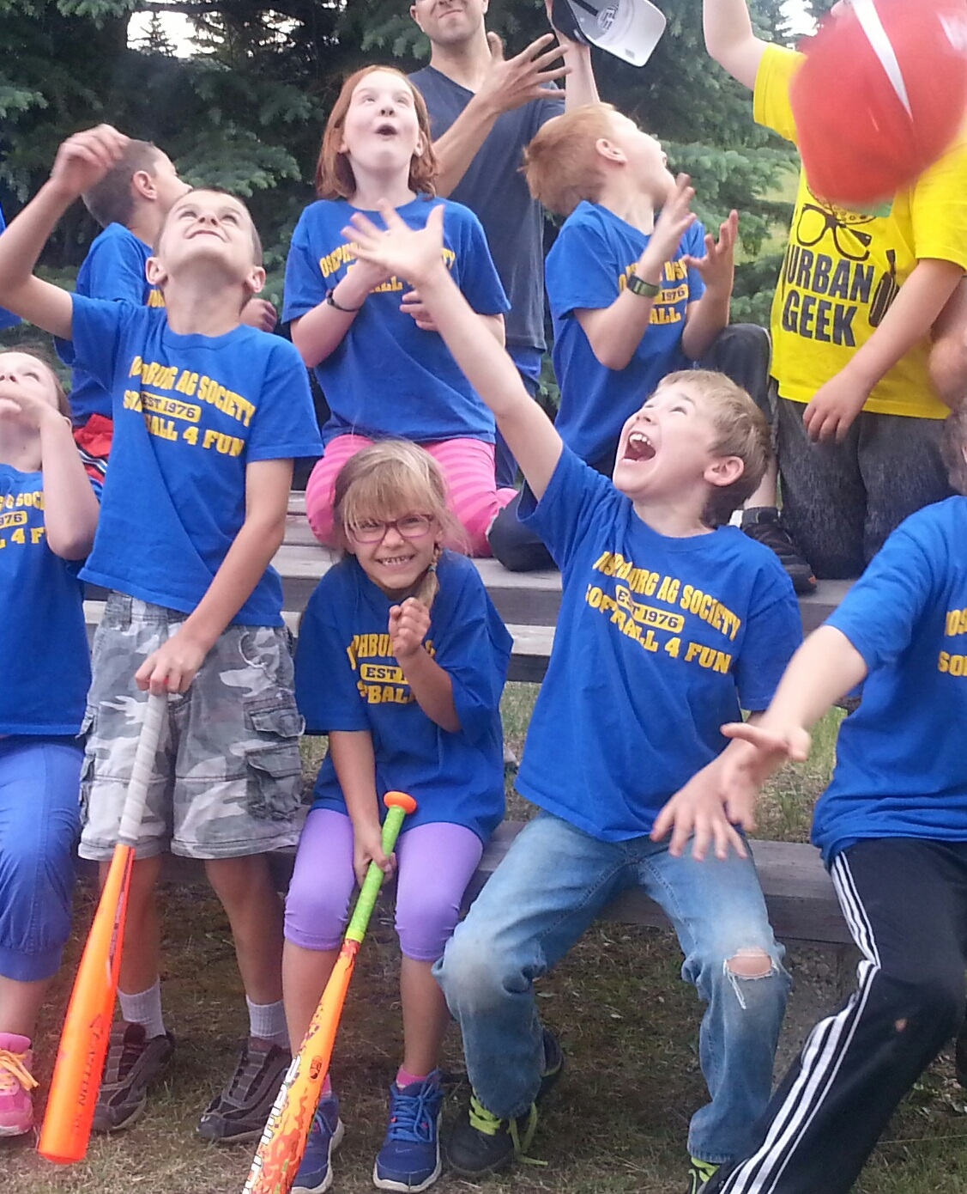
Proposed LIMITED Registration & Return to Play Details
Assumes that the current AHS restritctions are removed by May 26, 2021
- Registration Dates – May 9, 2021 to May 26, 2021 –
- Registration Fee - $35 per player, plus $10 per family annual membership fee to Josephburg Agricultural Society. Detailed Return to Play Plan can be requested via email … or Questions answered by contacting our Ball Program Coordinator – Billie Borys - at 780-905-6951.
- Players, Volunteer Parent Coaches and Sanitization Cart Parent Volunteers (also a Spectator who is resposible for the teams Sanitization Cart and cleaning equipment after each game) will receive a T-shirt and Ball Cap to keep.
- Players must bring their own Ball Glove, appropriate shoes, water bottle and a Ball Helmet.
- Requests accomodated where possible to have Player friends or cohorts on the same team.
- 2 Parent Volunteer Coaches needed per team of 8 players. In addition each team needs one Parent Volunteer who will take the Portable Sanitization Cart (on wheels) from the Playground Garage to the playing area, assist with Cleaning of Equipment after each game, then return the Sanitiztion Cart.
- All Registrations will be done online at josephburg-ag.ca

Anticipated Return Start Dates
- Option A (EARLY START) - Monday, June 14, 2021 to Wednesday, August 11, 2021
- Option B (EXPECTED START DATE) Monday, June 21, 2021 to Wednesday, August 18, 2021
- Option C (LATE START) - Monday, June 28, 2021 to Wednesday, August 25, 2021

Monday and Wednesday Training Times and Dates
Tee-Ball 4 FUN – 6 to 7 pm –
- Diamond 3 (North Diamond) –
  - 3 groups of 10 consisting of 2 Coaches and 8 players each plus 3 groups of 10 Spectators.
- Diamond 2 (Center Diamond)
  - 3 groups of 10 consisting of 2 Coaches and 8 players each plus 3 groups of 10 Spectators
  - Maximum Tee-Ball Registration – Diamonds 2 and 3 = 48 players (OR 64 players with Overflow)
- North West Soccer Field –
  - If needed for Overflow Tee-Ball 4FUN Registration and subject to meeting all requirements, this field could accommodate 2 groups of 10 consisting of 2 Coaches and 8 Players each, plus 2 Groups of 10 Parent or Guardian Specators
Softball 4FUN – 6 to 7:30 pm –
- Diamond 1 (South Diamond)
  - 3 groups of 10 consisting of 2 Coaches and 8 players each plus 3 groups of 10 Spectators.
  - Maximum total Softball 4FUN Regisration that would be allowed = 24 players with 6 Coaches
Examples of Tee-Ball 4FUN Training Activities
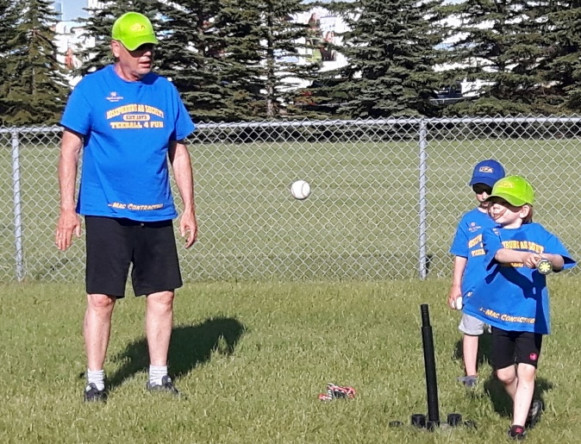
Batting Station – Coaches wear masks, maintain a 2 metre distance from Player. Teams will rotate each through at least 3 Skill Stations. If AHS rules allow later in the season Training could change to Play.
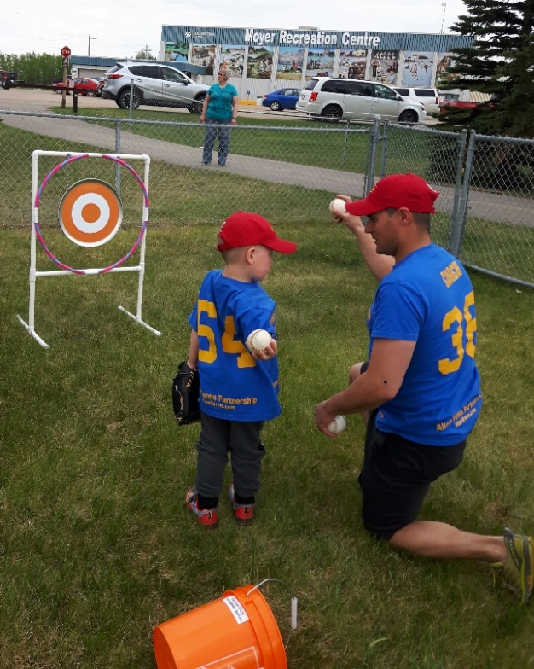
Throwing Skill Stations - made of with a PVC pipe stand . . . a Hola Hoop taped to the frame . . . a noise making Pizza Pan hung by chain that clangs and swings when hit . . . with a vinyl Bullseye target .
Masking & Cleaning Requirements
- Coaches would be required to wear masks at the Ball Diamonds and keep 2 metres from Players. Players are not required by AHS to be Masked, but could choose to do wear Masks if desired.
- Cleaning Station Parent Volunteers would be required to wear masks when interacting with Coaches WHILE cleaning equipment at the end of each game.
- All Balls, Bats and Equipment used would be wiped down at the end of each game using the 70% Alcohol wipes, 70% hard surface cleaner and paper towels located on each of the Sanitizer Carts.
- Garbage collected from the 5-gallon pails located with each Sanitizer Cart would be emptied into garbage bags at the end of each day and left in the Playground Garage for disposal.
Spectators – Would be spaced 3 metres apart and sit opposite fixed Spectator signage
- Spectators would be limited to the parents or guardians of a child player.
- Would be expected to use Hand Sanitizer before entering and after leaving the Ball Diamond area.
- Would be required to bring their own Lawn chair and not use the aluminum bleachers.
- Would be asked to seat themselves opposite the fixed signs that will be mounted to the fencing 3 metres apart. Spectators would be limited to the parents or guardians of a player.

